**Define SPA and Its Benefits**

SPA (Single-Page Application) is a web application or website that interacts with the user by dynamically rewriting the current page rather than loading entire new pages from the server. This approach gives a smoother and faster user experience, similar to desktop applications.

**Define React and Identify Its Working**

React is a JavaScript library developed by Facebook for building user interfaces (UIs), especially for single-page applications. React allows developers to create reusable UI components that manage their own state.

**How React Works:**

* Uses a Virtual DOM to optimize updates.
* React elements (components) define how the UI should look.
* When the data/state changes, React:
  1. Updates the Virtual DOM.
  2. Compares it with the previous Virtual DOM (diffing).
  3. Applies only necessary updates to the real DOM.
* This results in efficient rendering and faster performance.

**Differences Between SPA and MPA**

| **Feature** | **SPA (Single-Page Application)** | **MPA (Multi-Page Application)** |
| --- | --- | --- |
| **Page Reloads** | No (uses AJAX, dynamic updates) | Yes (full reload on every navigation) |
| **Speed** | Faster (once loaded) | Slower (frequent server calls) |
| **Data Loading** | Loads data via APIs (REST/GraphQL) | Loads data with each page request |
| **Development** | Frontend & Backend often separated | Backend-rendered views |
| **SEO** | Harder (needs server-side rendering) | Easier (static pages indexed by default) |
| **Examples** | Gmail, Facebook, Twitter | Amazon, LinkedIn (older version), eBay |

**Pros & Cons of Single-Page Application**

Pros:

* Fast Load Times After Initial Load
* Smooth Transitions (No Refresh)
* Frontend and Backend Decoupled
* Reusability of Components

Cons:

* SEO Challenges
* Initial Load Can Be Heavy
* Security Risks (Exposed JS logic)
* JavaScript Dependency (If JS is disabled, app may not work)

**Explain About React**

React is an open-source JavaScript library used to build user interfaces, primarily for SPAs. It emphasizes component-based architecture, state management, and declarative UI design.

**Define Virtual DOM**

The Virtual DOM (VDOM) is a lightweight in-memory representation of the real DOM. It’s a copy of the actual DOM used by React to efficiently update the UI.

**Features of React**

Major Features:

* Component-Based Architecture
* Virtual DOM for Fast Rendering
* Unidirectional Data Flow (from parent to child)
* Reusable Components
* Supports Hooks for State and Side Effects
* Efficient State Management (via context API or external tools like Redux)
* Developer Tools for Debugging
* Server-Side Rendering Support (via Next.js)

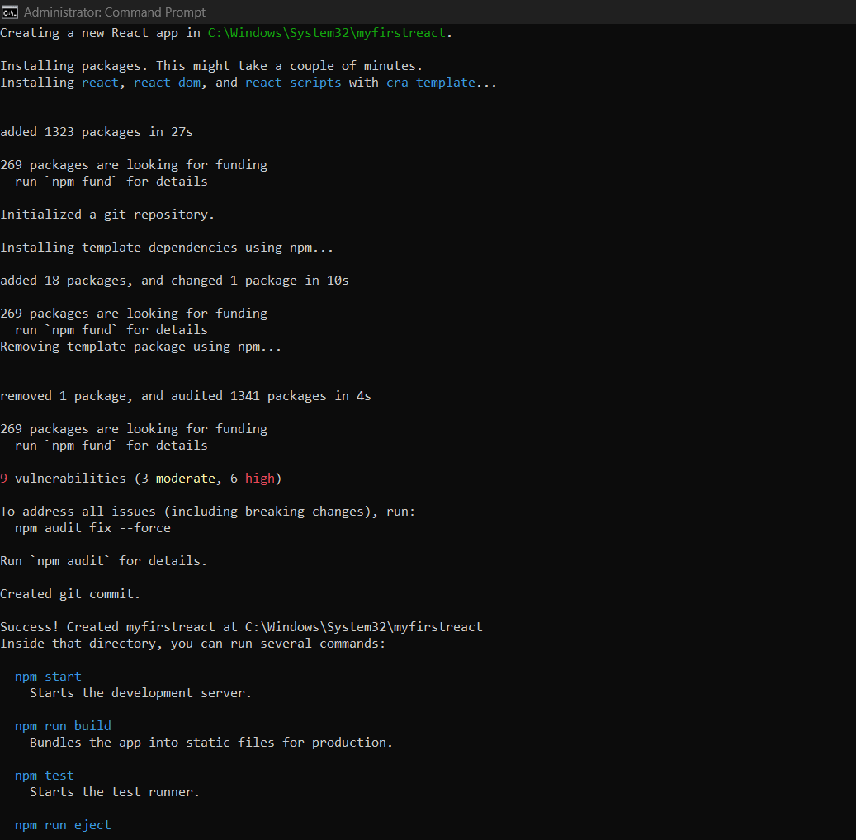

**Output on the Browser**

